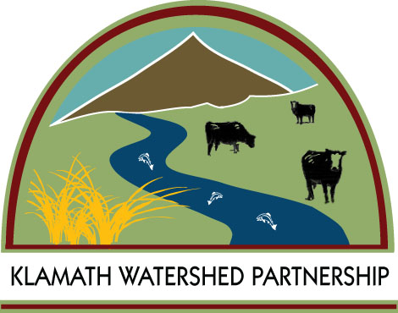
Klamath Watershed Partnership
205 Riverside Drive, Suite C
Klamath Falls, OR 97601
Phone (541) 850-1717 ~ Fax (541) 850-8001

March 17, 2023

Landowners in the Lost River Area:

The Klamath Watershed Partnership (KWP) has been awarded a grant from the Fremont-Winema National Forest for Weed Mitigation in the Lost River Area. Through this grant, landowners will be given an opportunity to partner with the KWP on a cost/share program to treat their noxious weeds. KWP will provide the labor and equipment for application through the Klamath County Weed Program, and landowners will contribute the cost of the herbicides applied to their property. Monitoring and evaluation will be conducted by KWP in cooperation with landowners, which will involve pre and post photo sites and vegetation surveys.

If you are interested in participating in this program, please let me know and send me the signed agreement (attached) as soon as possible. You may mail, fax, or email to the address above.

Thank you,

Jeff Kerber
Grants and Projects Administrator
(541)850-1717 Office
(541)850-8001 Fax
jkerber@klamathpartnership.org

Lost River Weed Eradication
2023 RAC Grant

Landowner Weed Management Agreement

The purpose of this agreement is to identify the role and obligations of each party involved in the Lost River Weed Eradication project. Land eligible for treatment is located along the river corridors as well as ditches and streams that flow to the rivers. Riparian areas and lands immediately adjacent to these zones are also eligible for treatment.

Specific obligations of each party:

The landowner will:

- Agree to the implementation of the weed control practices on his/ her property, taxlot(s) ________________________________________________________.

- Provide payment to Klamath Watershed Partnership (KWP) for the completed tasks as described in the Weed Management Plan, to be developed by Klamath County, KWP and the landowner. This payment amount will be based on herbicide type and quantity needed to accomplish objectives of the Weed Management Plan.

- Agree to have KWP and Klamath County enter property (with advance notice) on foot and by truck or UTV/ATV as needed to develop a Weed Management Plan, take photos of pre- and post-treatment areas, and to spray the weeds.

- The landowner self certifies that he/ she owns the property on which weed treatments will occur.

Klamath Watershed Partnership shall:

- Agree to implement the tasks described in the Weed Management Plan.

- Obtain written or verbal permission from the landowner before entering their property for project related activities and monitoring project success

- Bill landowner for cost of herbicide based on type and quantity needed to accomplish objectives of the Weed Management Plan.

Klamath Watershed Partnership

Signature:___________________________ Date:____________

Landowner
Name:
Physical Address:
Mailing Address:
Daytime phone:

Signature:____________________________ Date:

